Rathbone SICAV Multi-Asset Total Return Portfolio
Update, February 2020
Overview
Global markets have had a terrible time recently as the severity of the impact of Covid-19 on health as well as economies became all too apparent. Markets are unlikely to base out until the number of cases in Europe and the US show signs of peaking, which could be three to four weeks away. Until then, fear and uncertainty are driving sentiment. We wanted to let you know how we are navigating our way through these turbulent times and remind you of the importance of looking beyond the short-term fears and concerns.
The US dollar is the number-one harbour for global investors during periods of market stress. That’s why it has gained about 6% against a basket of major currencies between the beginning of the year and late-March. Meanwhile, the pound has gone in the other direction. It has fallen about 10% against the dollar since the beginning of March, hurting small and mid-cap UK stock prices. That can partly be explained by the pound being a ‘risk-on’ currency that tends to do well when the global economy is improving and do terribly when it isn’t. We increased our exposure to the dollar by unwinding more than half of our currency hedges and added to US Treasuries. We’re ready to put them back on again if the current momentum falls.
We are confident that our portfolio is in good shape, yet we have been stress-testing every company we own by reviewing its balance sheet and debt levels; you can never be too prudent. With the exception of oil stocks, our companies tend to be asset light and have high free-cash-flow yields, which basically means they’re generating enough cash to cover their costs. We also look for low debt to earnings before interest, tax, depreciation and amortization (EBITDA); we don’t want businesses with more debt than they can afford. Our hedging strategy is under review and while sterling looks undervalued, we may see more weakness in the near term. Currency management is nigh on impossible, so our priority is to ensure we have sufficient risk-off protection.
Some of you are asking what we do and don’t own, given how much the pandemic will weigh on some businesses and present opportunities to others. Rest assured we own no travel agents, gambling firms, restaurants, pubs, hotels or airlines. There are no general retailers either. There are some big falls happening in illiquid alternative income assets, such as aircraft leasing, and I can reassure you that we have virtually zero exposure here. We have no commercial property either. And in fixed income we have almost no high yield bonds and very little investment grade. We are confident in the bonds that we do own – held for the secure income streams they offer. Importantly, they form part of our ‘equity-risk’ bucket, as we knew liquidity is much more challenging when markets are stressed. Predominantly, our bonds are government debt that is held in our liquidity bucket.
We have a strategy that we are sticking to through these difficult markets.
Our three-phase plan for our funds is:
- Rebalance our portfolios. That means we have been buying those assets that fall in value so they return to the proportion of our portfolio that we target. A simplistic way to think of this is to imagine you had a portfolio of 50% shares and 50% cash. Say the stock market falls 10%, your stocks now make up just 47% of your portfolio. Rebalancing would involve using some of that cash to buy equities to bring the portfolio back to 50/50.
- Add ‘net’ to our equities. Using our previous example, that means going further and actually increasing the percentage of equities in our funds. Executing this phase is slightly different. We are now focusing on supplementing our directly owned shares by also buying trackers, principally of the S&P 500 Index but also the FTSE 100 Index.
- Shift focus to cyclical and smaller-companies. After the second or third leg of market falls, we will start to increase our exposure to companies that we own in parts of the economy that should benefit most from a recovery in economic growth.
This plan involves a lot of buying. It always feels uncomfortable pulling the trigger at times like this, but we must remain disciplined. We buy companies with a five to 10-year view. We are very confident that we are adding to world-class businesses that will produce excellent returns if we are patient. That’s the plan and we intend to stick to it.
This month’s trades
As the turbulence first kicked off, we entered phase one and rebalanced our portfolios. We temporarily moved into phase two by adding ‘net’ to equities before moving back to phase one, which is where we remain at the time of writing. We’re also supplementing our directly owned shares by buying trackers, principally of the S&P 500 but also of the FTSE 100.
The VIX S&P 500 volatility index spiked higher than levels seen during the global financial crisis and we used the opportunity to sell half of our July put contracts for a significant profit – we also own December contracts. Puts give us the option to ‘sell’ our US exposure at a set level in return for paying a small premium (effectively this works like investment insurance). Because this level was much higher than the index at the time, our option was worth a lot of money. Selling part of our put contract has the effect of instantly increasing our portfolios’ net equity exposures as well. Our remaining put contracts remain ‘in the money’ (the S&P index level is below the ‘strike price’ that we can ‘sell’ at). These remaining puts continue to offer material support should markets fall further.
The lower market level has also presented us with a number of opportunities to add exposure to some quality companies who have exciting long-term prospects, but whose valuations were too expensive for us just a few months ago. We also added to US equities as markets had dropped to our entry point, then traded again off the continued lows. We also added to short-term US Treasuries to increase our dollar exposure as a hedge should we see a further capitulation in markets.
Outlook
Markets stumbled at the end of February as Covid-19 spread beyond Asia. They sold off more significantly in March as it became evident that the virus was spreading around the world at an alarming pace. Western governments were caught with inadequate preparations and a chronic lack of medical supplies and capacity to deal with a pandemic.
Thankfully, most nations have responded quickly with stringent measures to slow the spread of the virus and economic measures to support people and businesses. Most of us are now living in lockdown as commerce, church, sports and general society has been brought to a shuddering stand-still. Yet, even as the world is put on ice, the financial markets continue whirring away. And whirr they do. The moves – both up and down, but mostly down – have been truly astonishing. Some investors see no hope on the horizon, others see huge bargains. Some see repulsive risk, some see the allure of opportunity. All of them, though, are looking at the same assets and the same world.
No-one knows how long the pandemic will shackle economies, businesses and households. We certainly don’t. But we do know that governments around the world have extended unprecedented loans, grants and tax holidays in a bid to encourage companies to retain their staff throughout extended furloughs. If successful, this should reduce the number of people laid off and help prevent a terminal cycle of lessened spending leading to more lay-offs leading to more lay-offs leading to a multi-year depression. Central banks have stepped up to the plate as well, with every major central bank slashing interest rates, unleashing quantitative easing and flooding vital lending markets with money. In short, our politicians and technocrats have thrown as much as they could at this problem.
Investors tend to focus on GDP, almost to the exclusion of all else. It’s the base line for investment cases, the yardstick for judging a company’s earnings, for assessing the yield offered by a government bond. But times like this remind us that growth isn’t everything. Economic growth is way to judge the commercial performance of a society, but it has its trade-offs. And it doesn’t always have to be maximised, strange as it sounds for an investor to say. Governments around the world are trying to reduce GDP in order to beat Covid-19. This is a short-term measure that, all going well, will be reversed soon. This means that GDP and other economic metrics that we investors are used to watching will, over the coming weeks and months, plumb lows that we have never seen before. Some investors, suddenly without short-term indicators, will panic and create a lot of volatility. Newspapers will run doom-laden headlines about how measure X is at its lowest level ever. But you have to remember: lower GDP is the aim of government and our society for the coming months because that’s how we will stop the spread of the virus. This is not forever.
Many businesses and households will face a cash flow crunch in the coming weeks and months. Most particularly the self-employed, the zero-hours workers, and the whole of the retail and hospitality industries. Most important for us is whether the announced government policies, round the world, work as intended and get to the people and small businesses that need them. If they are executed poorly, the chances of a strong recovery once the virus has been beaten back will be greatly reduced.

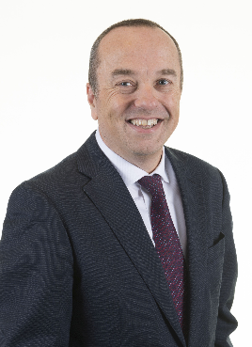 | 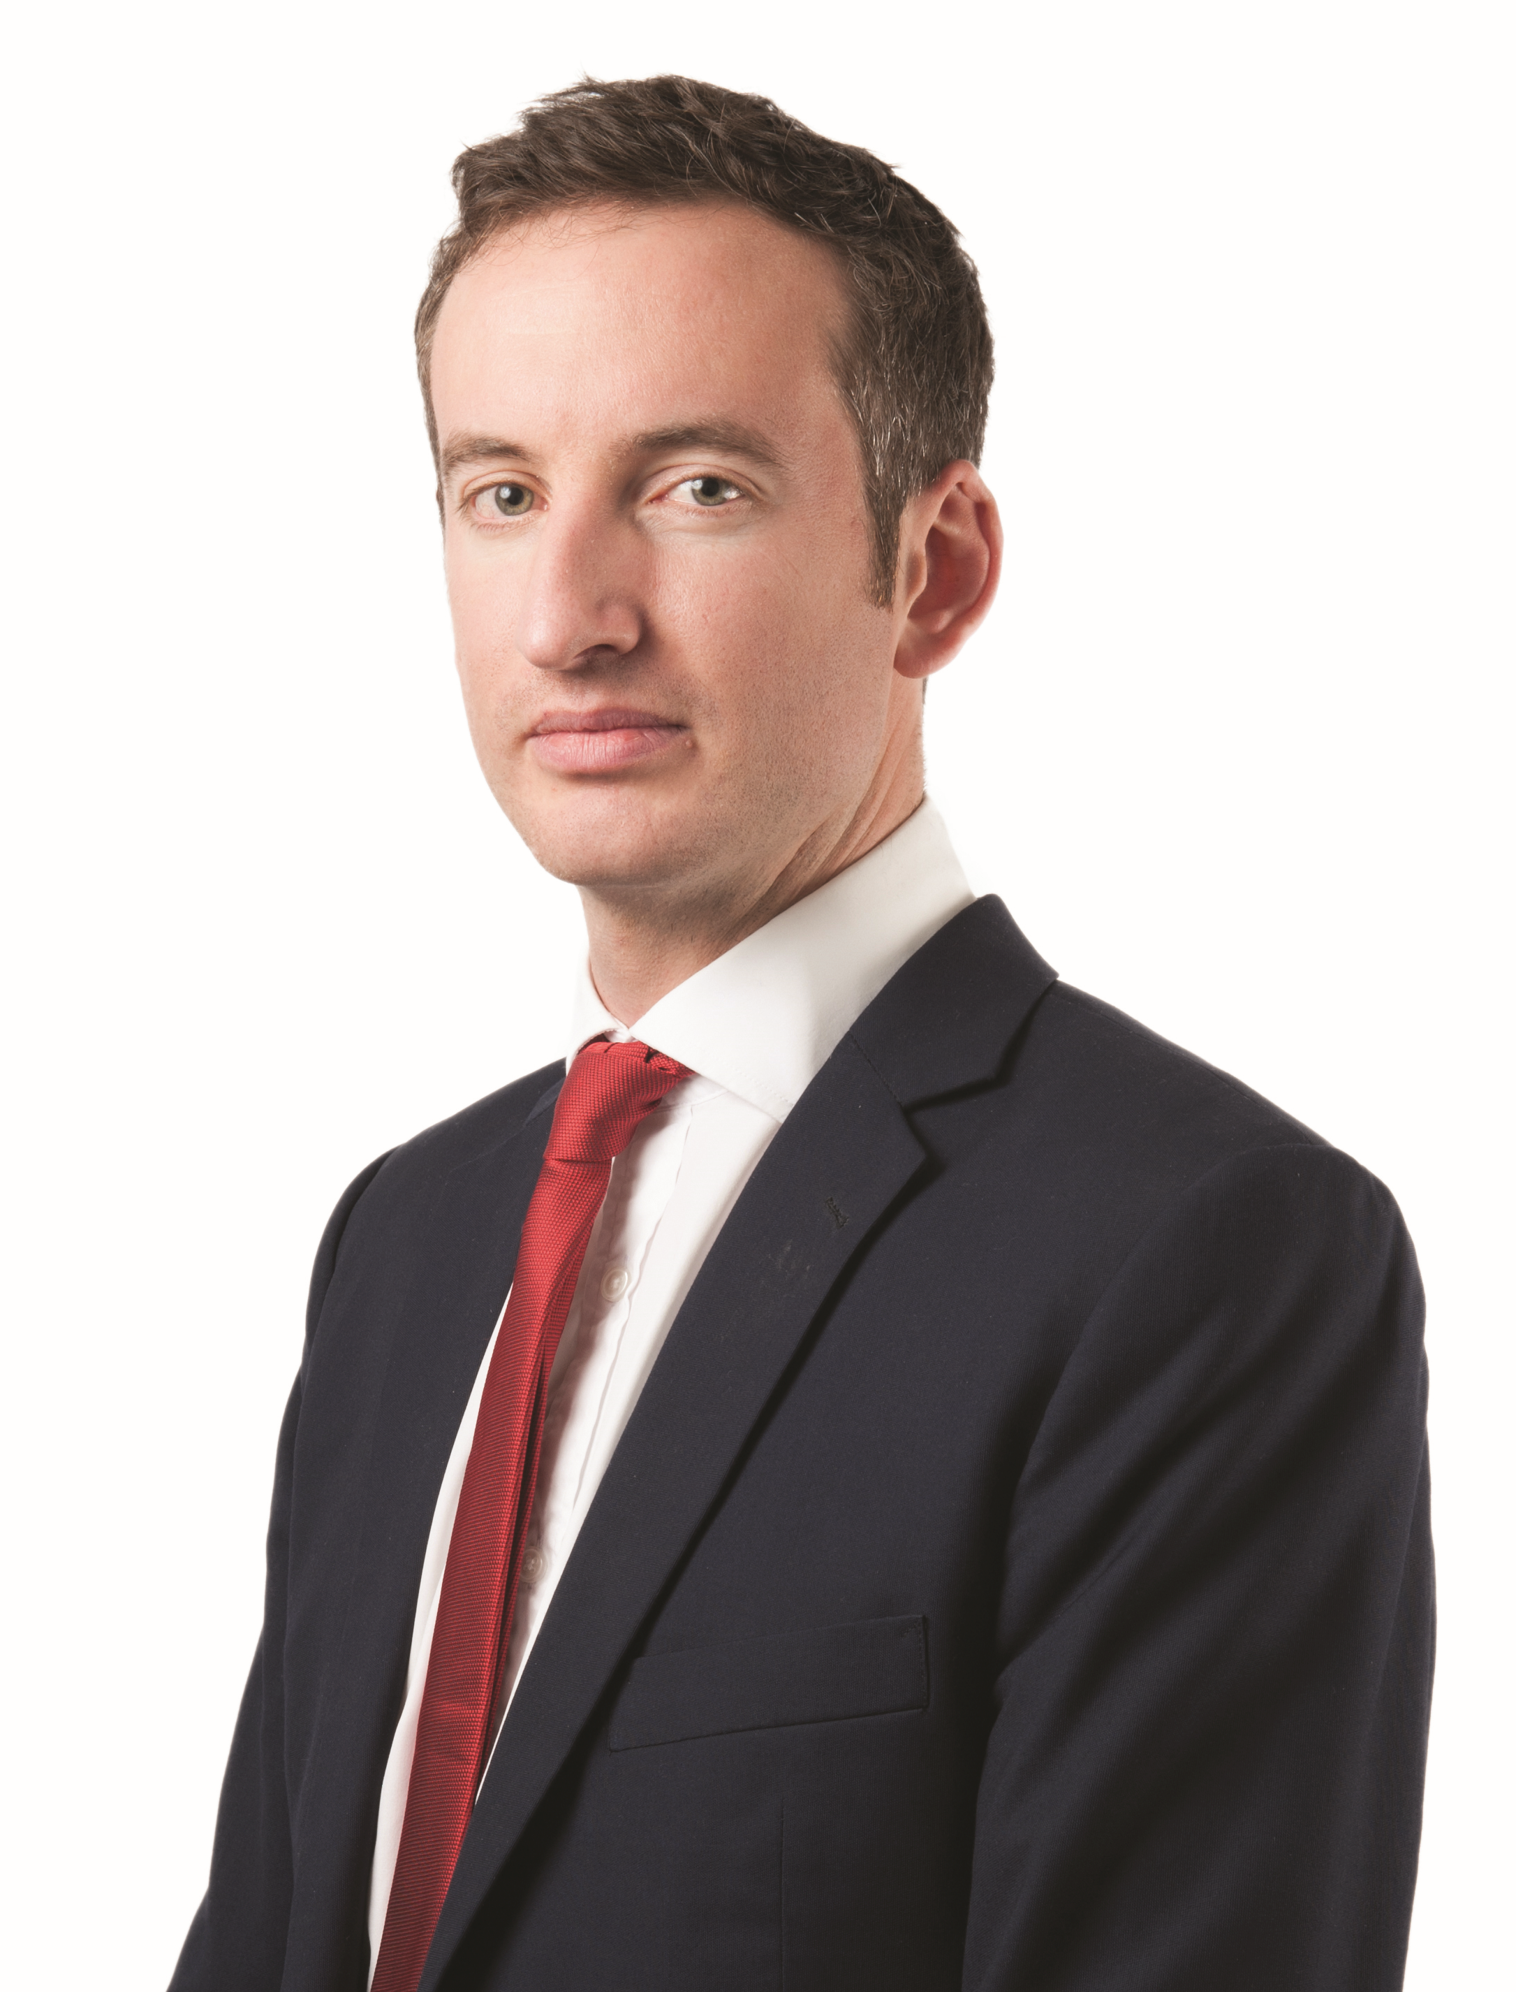
David Coombs | Will McIntosh-Whyte
Head of Multi-Asset Investments | Fund Manager

This is a financial promotion relating to the Rathbone SICAV Multi-Asset Enhanced Growth Portfolio. Any views and opinions are those of the investment manager, and coverage of any assets held must be taken in the context of the constitution of the fund and in no way reflects an investment recommendation. The information contained in this note is for use by investment advisers and journalists and must not be circulated to private clients or to the general public. Source performance data, Financial Express, single priced, mid to mid, net income re-invested.

When operating in the EEA, Rathbone Unit Trust Management works in partnership with a tied agent. In Europe we market our funds through Rathbone Funds Advisers, Unipessoal Lda. (“Rathbone Funds Advisers”) a company acting as a tied agent to Carne Global Financial Services (Europe), Unipessoal Lda. (“Carne Global”) which is an investment advisory firm authorised under MiFID II and supervised by the Portuguese Securities Market Commission - the CMVM (Comissão do Mercado de Valores Mobiliários). Rathbone Funds Advisers is registered in Portugal and has been appointed by Carne Global to provide investment advisory services on its behalf in relation to financial instruments, in particular units or shares in undertakings for collective investments.

